Local Digital Repositories
A local data storage repository for a college campus

Seema Vishwakarma
Asst Professor
Vidyalankar School of Information Technology
Mumbai, India
seesbv@gmail.com

Kunal Baghel
T.Y. B.Sc IT
Vidyalankar School of Information Technology
Mumbai, India
kunalbaghelkb@gmail.com

Abstract— Digital repositories are developed and enhanced as a very important part of research infrastructure. Every institute should develop a strategy for providing repository services as a part of sustainable resource. The paper concentrates on the local repositories developed for an institute(college) which will address problems and limitations faced by the users at different hierarchy. The paper proposes an architecture for developing an entire repository service for an organization which will form a strong information managing infrastructure in the long run. This will help students and the college to get connected with wide variety of data available in the repositories which can also we enhanced on a regular basis.

Keywords—repostitories , architecture, local

Introduction
In today’s world of computer where data is created enormously by every organization repositories plays a major role. Open access repositories are available for accessing data available on internet. But if the institute wants to upload its digital contents and information for easy access by college students and faculty members then it has to rely on Facebook groups, Google plus groups, dropbox etc. This requires uninterrupted and dedicated internet connection. Students don’t have full access to internet due to security reason and the routers are needed to be installed and set up at different location for proper access of internet speed. The solution offered through this paper works totally on intranet and hence resolves the dependency on internet. Files will be shared amongst teachers and students on local database server through will the data could be accessed easily without any dependency on the internet. Here the students don’t have to connect to the internet but they can connect to the local Wi-Fi in the campus with the local static Internet Protocol address. The local URL will redirect the authorized students and the faculty members to the local digital repositories of the college where the users can access their relevant data and information.

Architecture
The architecture of the entire model is designed considering a campus with certain hardware and software specifications. The architecture will be needing a local server, Wi-Fi enabled campus and handheld devices for accessing the data. The intended audiences will be assigned certain rights and privileges to the different levels of users including students, faculty member’s admin and super admin roles.
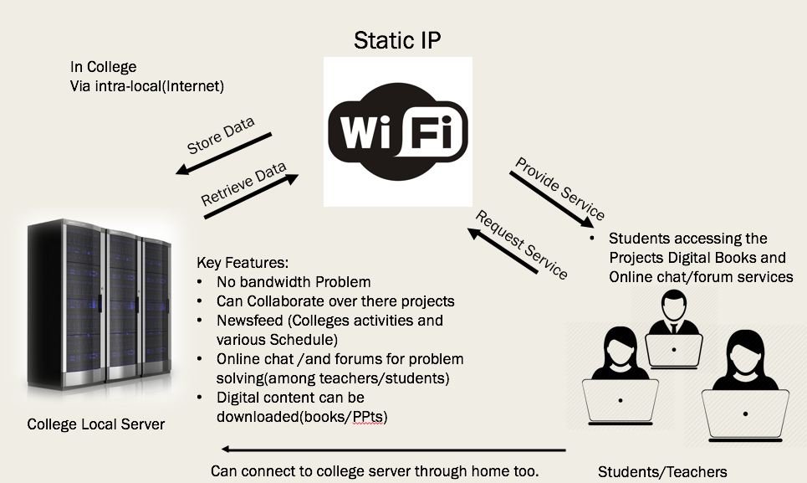
Figure 1.1 Architecture for local digital repositories

College local server
The functioning of the local digital repository is via static IP eg https://182.234.142.60:8080/typrojectf which will belong to the college server. This server will be the main server consisting of web server and its services running on it. Additionally, a Cache memory and a storage purpose a hard disk with the relevant capacity can be used. SSD (Solid State Drives) is been suggested in the paper which will act as a cache for the entire architecture and for storage purpose, the traditional hard drives will be used.
The server will have its motherboard as the one present in the usual PC. The capacity or the requirement of the server can be enhanced depending upon the requirement and the number of users in the college. Linux operating system with its preinstalled drivers and hardware will operate the entire architecture for running the system. Apache or glassfish server can be used to deal with web server request made by the client side.
This whole system will be installed in college itself so all the security implementation is needed inside the college server itself. MYSQL or oracle Database will be used on server side for data storage and manipulation purpose. The website will be code in the JavaScript, JSF based on the MVC architecture to maintain the integrity of the repository so to keep the view, business logic and control separate. Since the server is running locally inside the college there won’t be any bandwidth problem cause if the college uses an internet connection to provide these facilities it is expensive and also there is always bandwidth and speed limitation issues.

Wifi enabled campus
In order to provide repository services and to run the system, wifi connection is needed. Since the college is going to have the servers and in order to provide these services locally the college needs to be Wi-Fi enabled. The server will run locally on the wifi connection. The college needs to implant the high speed enabled Wi-Fi capable of 1 gbps up and 1 gbps down in the college in order to provide maximum number of connections pre-area.

Intended Audiences
The guidance and recommendations included here are primarily intended storing details related to libraries, colleges, various student’s committee groups like (student council), coder’s committee, and scholarly publishers and are specifically aimed at college students, teachers and non-teaching staff for easy accessibility and availability.
The rights of user’s will totally depend on the login valid authentication provided by the college to them eg. Committee heads have the rights to edit and post content on the repository newsfeed. Similarly, the repository admins might have the capability to check on the post and to see what items must be kept or removed from the digital repository.

MVC architecture
JSF technology is a framework for developing, building server side User Interface Components. These components can be used in a web application. Data consistency and data integrity could be achieved more smoothly using the MVC (Model View Control) JSF Architecture. This architecture consist of three parts : model, view and control. In the major components “model” the business logic is coded. It maintains the layer of data function that basically acts upon the databases. It also keeps the “view” and “control” separate. The view is the actual content upon which the user interacts and the controller acts as an architecture handler. Controlled decides when the data must be updated on the database or when the next view must be showed to the user upon his interaction.
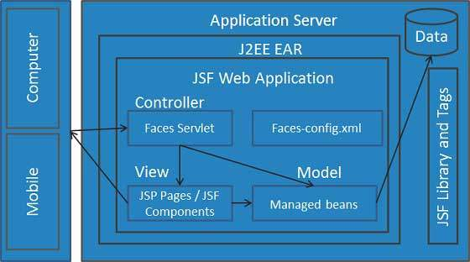

Benefits
Finally, complete content and organizational editing before formatting. Please take note of the following items when proofreading spelling and grammar:

Advantage to the institute
- Ease of setup, installation and maintenance
The set up and installation of the system could be done in the college campus. The hardware and software requirements for the repository is very less. It could also be able to run on the simple machine therefore the maintenance, setup and installation easier. The maintenance of the repository can be done by a staff member with the knowledge of hardware, the admin for the repository will look after the enhancement and working of repository database.

The installation of the repository will only require specific software. The software like the apache Tomcat and glassfish server are already available in Ubuntu or in Linux system environment. Installation and setting up of these servers are quite easy as they are open source and freely available on the internet. The maintenance also depends upon the life cycle and the type of hard disc and SSD. The involvement of the server room in the institute will play a major role in the project.

- Cost saving
This will make the internet usage and students involvement cost effective since the repository usage will make the internet usage to go down since regular stuff will be made available on the repository which make the students to use the repository instead of the third party services. From the below mentioned graph its evident that the students spend more time in college on repository related work. This includes studying alone, using online databases, using references, checking books etc.
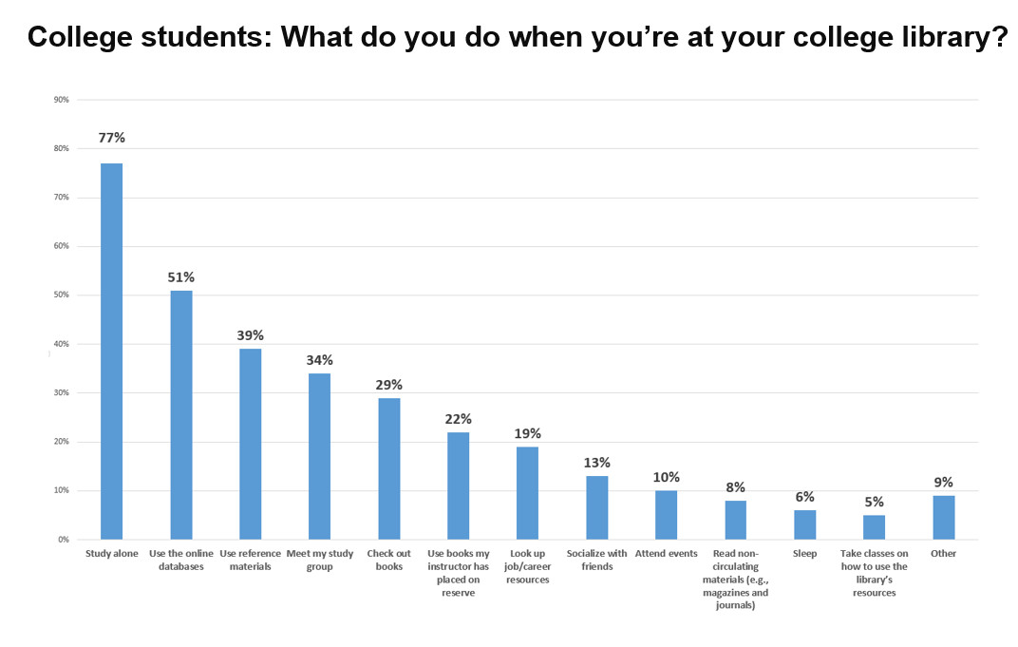

- Security: Data remains within the institute
The repository has a balanced database with secure access. Since all the data is for the college students, teaching and the non-teaching staff this makes the data secure from outsider from the institute.
The data is available on the local platform with the access allowed only to the authorized users.

- Easy backup and recovery
Backup of the data can be significant as per the number of users and strength of the institute or college but since the real usage may very hence the amount will depend on the institute to institute. But backing of data can be at ease by software available in the Linux systems which give the power to the admins of the database to backup data at the period sessions. So as same implies to the recovery of the data which depends on the backup status of the repository by the admin.
Since the repository runs on the general purpose hardware which can be meant as the failing of the system is very very low possibility.

Advantage to the Users
- Fast access
As there will be high bandwidth allocation and the SSD read write speed are very high indeed as of 1 gbps of write and 1.5 or 2 gbps of reading capability which means there won’t be any access problems.
This will allow faster and consistent performance throughout the repository can be provided to the users of the Digital repository.
- Easy upload and download
Since there will be consistent performance throughout the repository which will mean that the upload and download speed in and out of the repository will be definitely fast for the general user of the institute.

Model
As students will put the static IP on their device which will take them to the login of the page form their they can jump on to the newsfeed to take the latest information and the college schedules. As the admin of the various committee members can post the various content on the newsfeed. Since all this is happing in the colleges server there won’t be any speed issues. Students will also be able to download the content which is been uploaded by the college teachers or the other students on the repository. There will be the online forums where students will be able to put their issues on the forum where teachers will be able to view those problems. Since all this is happing locally there won’t be any bandwidth issues in the college.
We will also provide the digital books to the students through the repository. This whole concept of the repository will work on the port- forwarding to establish the local digital repository on the college network. The major sector of this project can be the code collaboration for the college students in the related IT/CS backgrounds where they can collaborate on their mini projects. This will make students to focus on the creation and help them to evaluate their technical skills.
This will not only help the college students but where committee members of various groups to utilize the repository to provide/inform about the college events and other related information. This will make college life more easy as they will have on tip information/College schedules.
Colleges can upload digital books and other digital contents on the repository from where students can download those content as per there need rather than searching it on the internet. Since there is forum on the repository students can submit what all digital books they would like to have on the repository.
A figure below shows pages from the local digital repository. The pages has its own local server coded using netbeans in JSF framework on MVC architecture. The entire repository consists of authorization for faculty members and students so that they can have their access to the data and can also upload some newfeeds . Newsfeeds is a timeline with latest schedules and information posted by any users of the repository. It will updated frequently based on the data posted by the users.

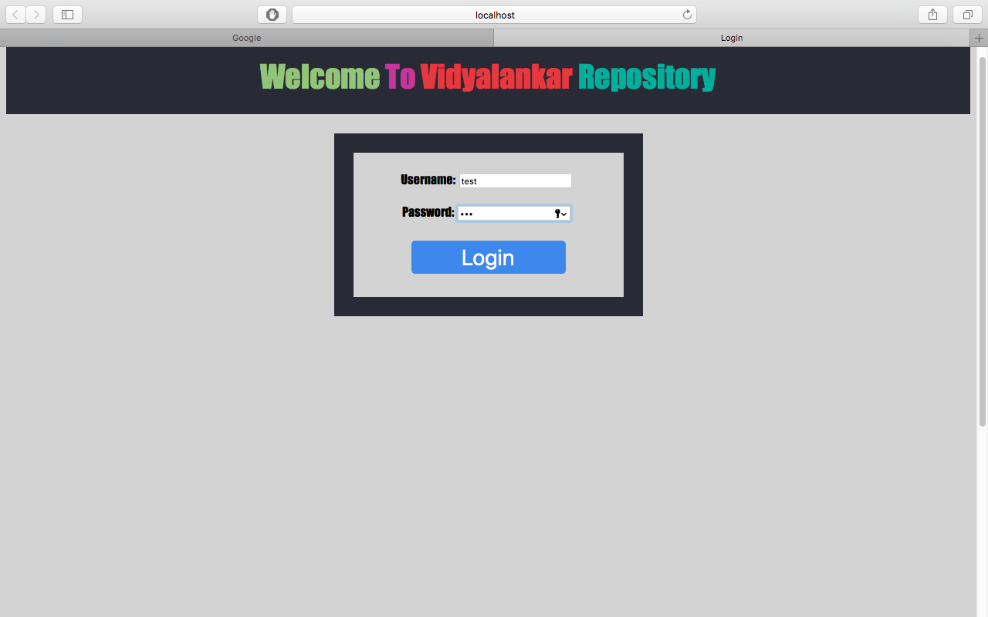

Login of sample digital repository.
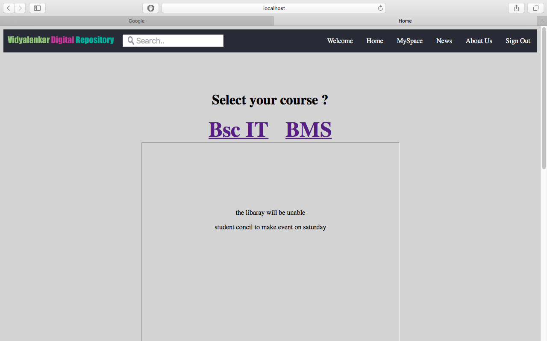

Sample shot of newsfeed.

References
- Introduction to digital libraries, howdhury, G. and Chowdhury, S. (2002) Introduction to digital libraries. Facet Publishing. ISBN 1-85604-465-3
- ResourceCenter - A Digital Learning Object Repository with an Integrated Authoring Tool Set
- Digital data storage system with improved data migration
- https://www.cengage.co.in/
- Stanford Digital Repository https://library.stanford.edu/research/stanford-digital-repository
- DSpace: An Open Source Dynamic Digital Repository

